Image | Name | Info | Price | Qty.
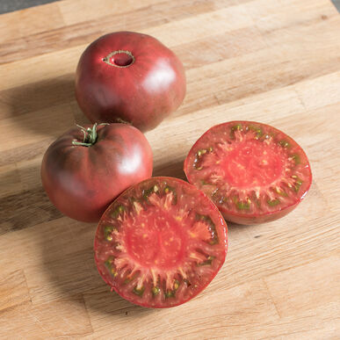 | Cherokee Purple | Organic Seed | $3/each  3” pot | 10
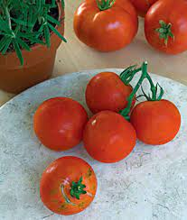 | 4th of July |  | $3/each  3” pot | 8
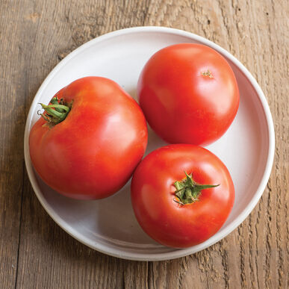 | Big Beef |  | $3/each  3” pot | 21
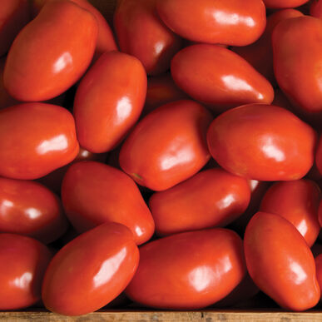 | Paisano |  | $3/each  3” pot | 12
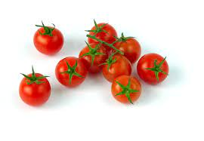 | Cherry |  | $3/each  3” pot | 12
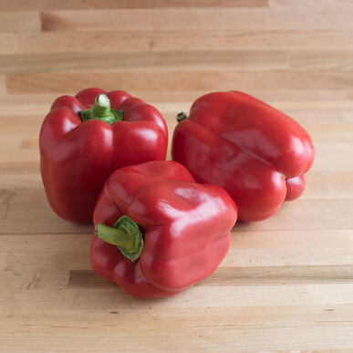 | Red Bell |  | $3/each  3” pot | 14
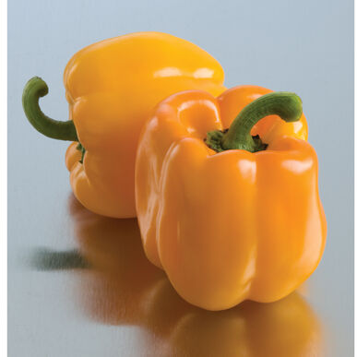 | Yellow Bell | Organic seed | $3/each  3” pot | 13
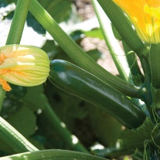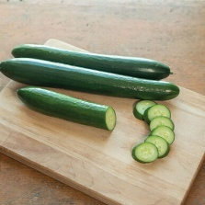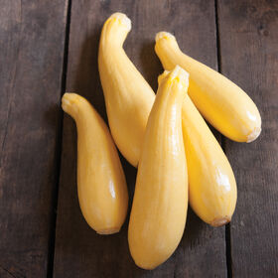 | Zucchini, yellow squash, cucumber |  | Sold in 6 pack squash mix (2 zucchini, 2 cucumber, 2 yellow squash)  $4/each pack | 7
 | Storm Sale – tomatoes and peppers | Mix of Brandywine, Martha Washington, Cherry, Cherokee Purple, Red Bell Pepper, Yellow Bell Pepper, Hot Pepper | $1/each | 30

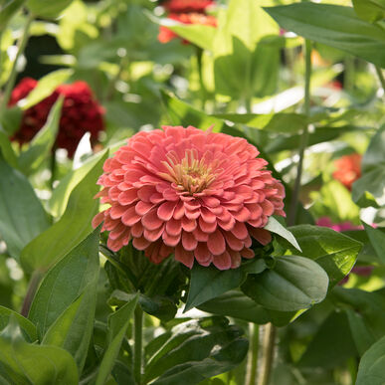 | Zinnia Benary Giant Salmon Rose | 4” – 6” double blooms | $2/each  Jiffy pellet – ready to plant | 10
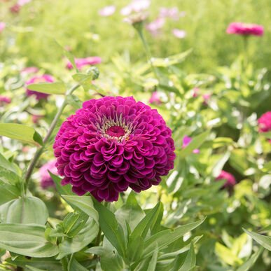 | Zinnia Benary Giant Purple | 4” – 6” double blooms | $2/each  Jiffy pellet – ready to plant | 10
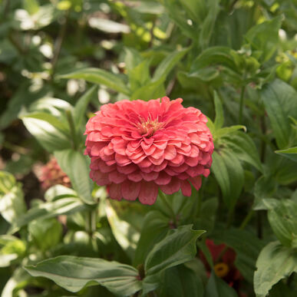 | Zinnia Benary Giant Coral | 4” – 6” double blooms | $2/each  Jiffy pellet – ready to plant | 10
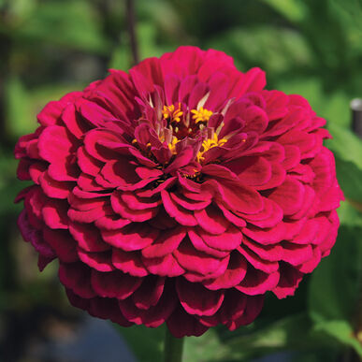 | Zinnia Benary Giant Wine | 4” – 6” double blooms | $2/each  Jiffy pellet – ready to plant | 10
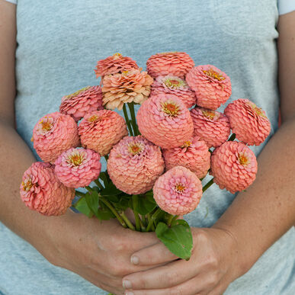 | Zinnia Oklahoma Salmon | 1 ½” – 2 ½” double and semi-double blooms | $2/each  Jiffy pellet – ready to plant | 22
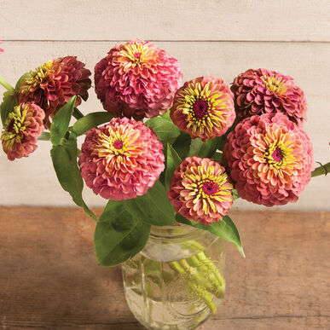 | Zinnia Queen Red Lime | 2” – 3 ½” blooms, mix of single, double and semi-double | $2/each  Jiffy pellet – ready to plant | 12
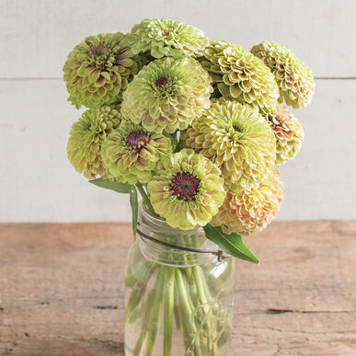 | Zinnia Queen Lime with Blush | 2” – 3 ½” blooms, mix of single, double and semi-double | $2/each  Jiffy pellet – ready to plant | 6
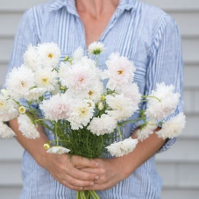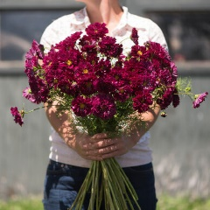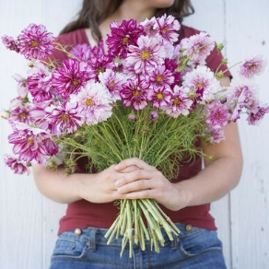 | Cosmos Double Click White, Cranberry and Bicolor Violet | 2” – 3” bloom | 6 pack mix  $4/each pack | 4

